**Step A – Clone the repository (if not already done)**

git clone https://github.com/SadiaTabas/SafeHer.git

cd SafeHer

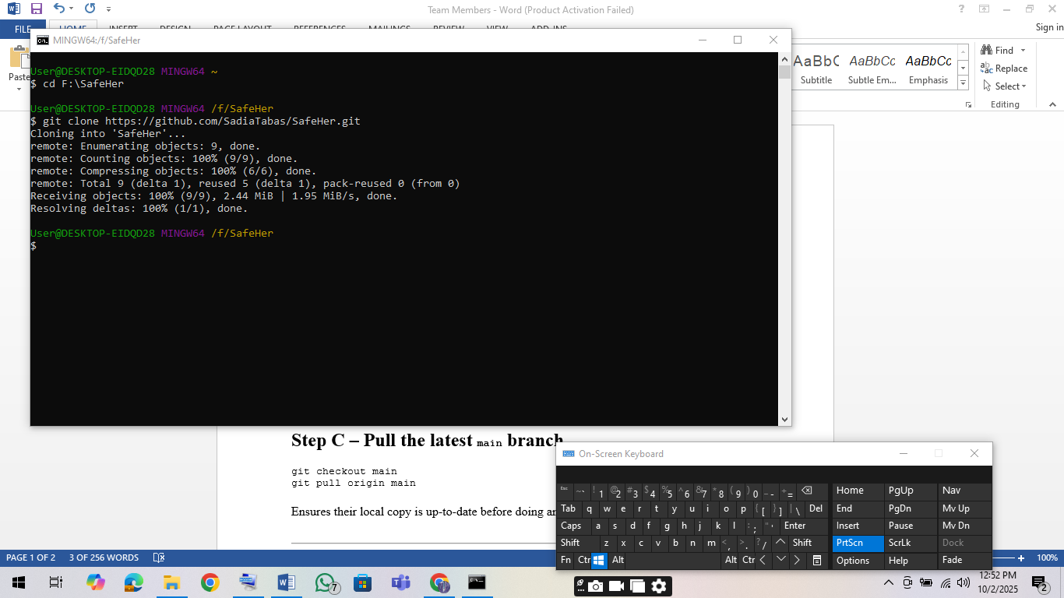

**Step B – Set up Git identity (if not already set)**

git config --global user.name " shama87"

git config --global user.email [nahin1757@gmail.com](mailto:nahin1757@gmail.com)

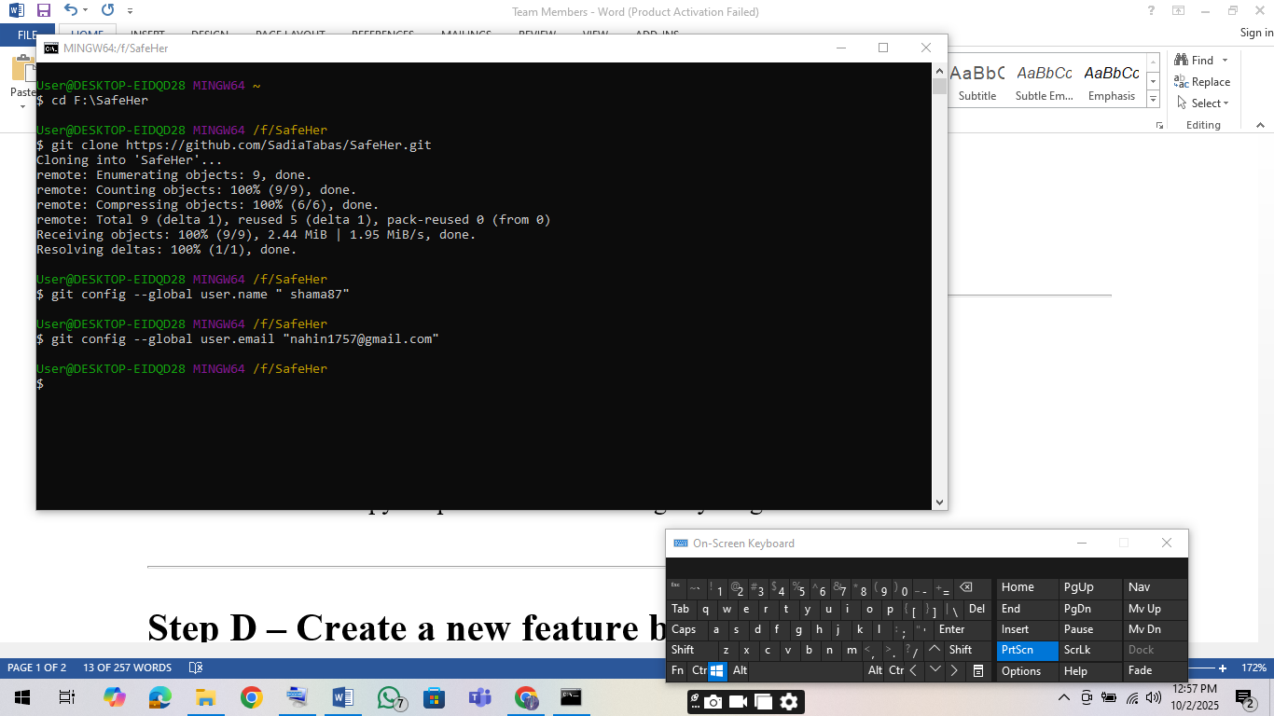

**Step C – Pull the latest main branch**

git checkout main

git pull origin main

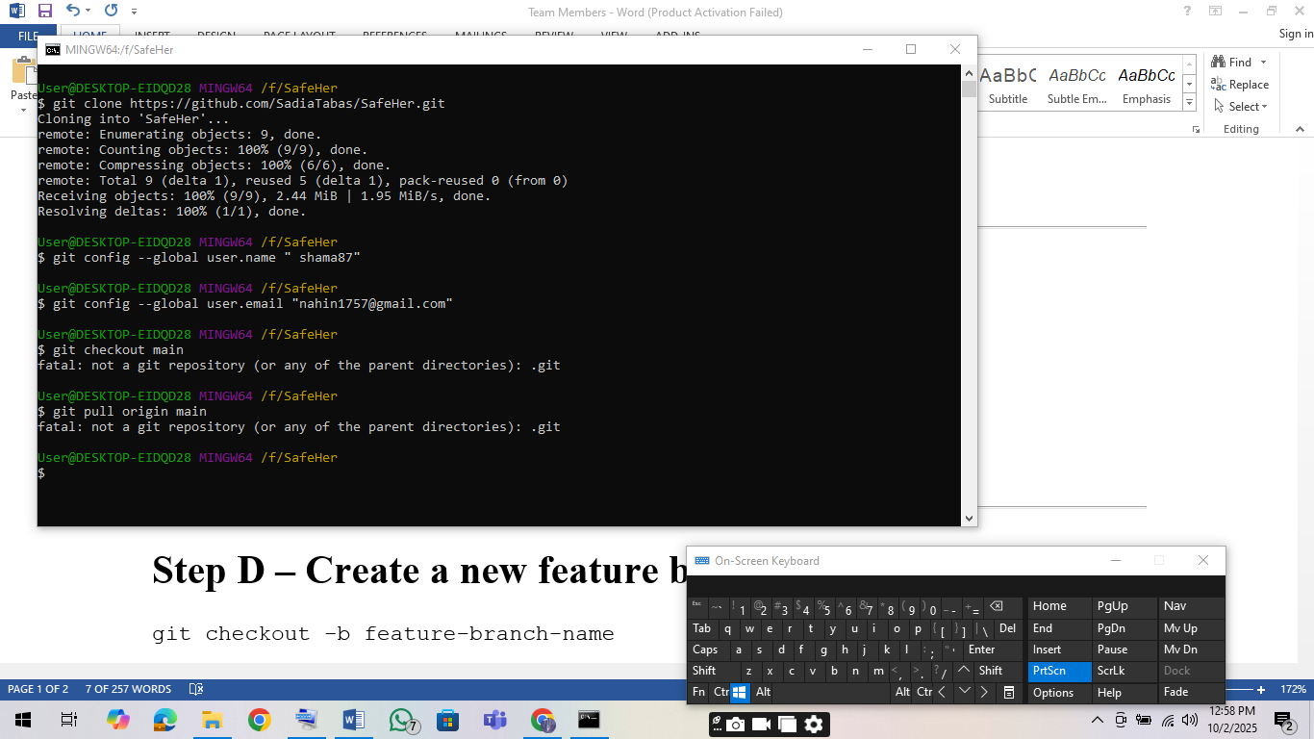

Ensures their local copy is up-to-date before doing anything else.

**Step D – Create a new feature branch for assigned work**

git checkout -b feature-branch-name

* Replace feature-branch-name with something descriptive, e.g., update-ui or add-login.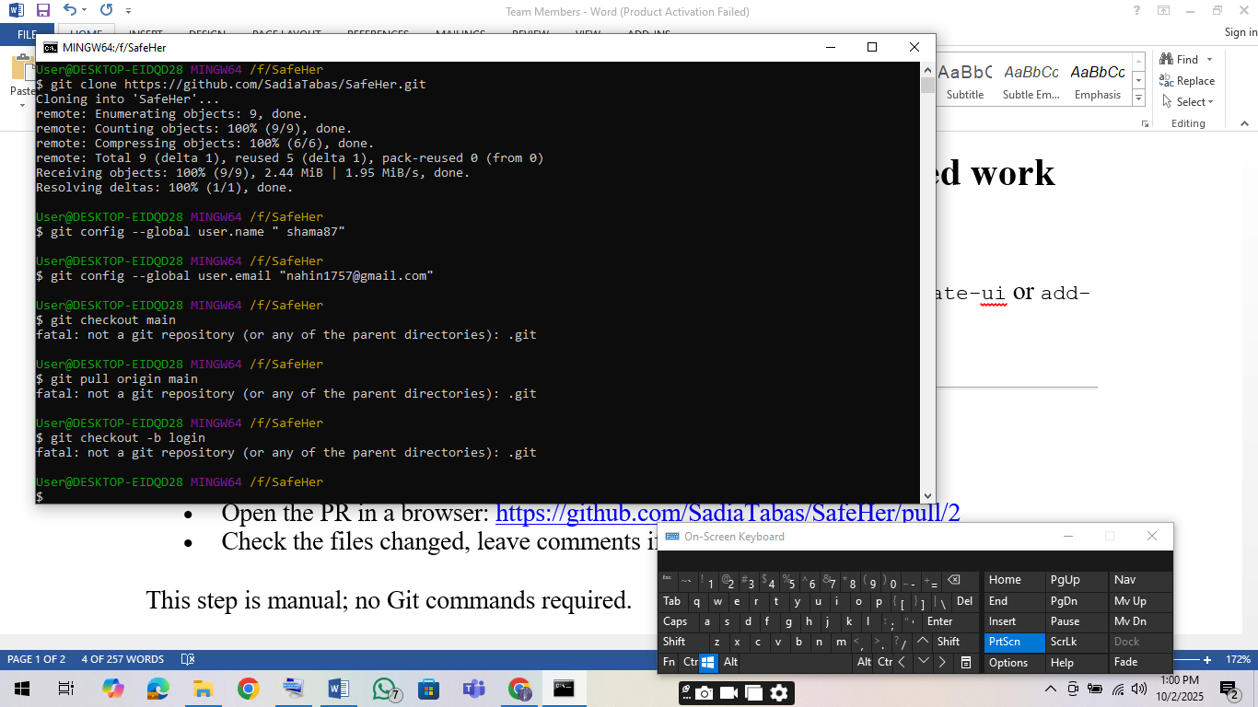

**Step E – Review your PR**

* Open the PR in a browser: <https://github.com/SadiaTabas/SafeHer/pull/2>
* Check the files changed, leave comments if needed.

This step is manual; no Git commands required.

**Step F – Merge the PR into main (if they have write access)**

# Option 1: Merge via GitHub website (recommended)

# 1. Click "Merge pull request" on the PR page

# 2. Click "Confirm merge"

# Option 2: Merge locally via command line

git fetch origin

git checkout main

git merge origin/add-doc-file-v3 # or the PR branch name

git push origin main

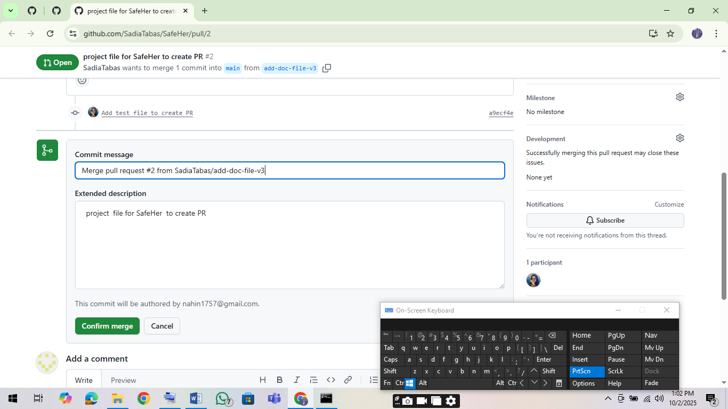

**Step G – Delete the feature branch (optional)**

git branch -d add-doc-file-v3 # delete locally

git push origin --delete add-doc-file-v3 # delete remote branch

**Step H – Pull the latest main branch after merge**

git checkout main

git pull origin main

Ensures everyone’s local repo has the merged changes.

**Step I – Start new work (repeat workflow)**

git checkout -b Personal Information

# Make changes, then:

git add .

git commit -m "Store personal information"

git push origin Personal Information

# Create a new PR for review